Table 2
Gerko Vink
Mean score and prevalence^^ of Responsible Research Practices (RRP), Falsification, and Fabrication stratified by Disciplinary Field and Academic Rank withput NA
Table of Contents

Packages used
For this document we use the following packages
library(dplyr) # Data manipulation
library(mice) # Data imputation
library(magrittr) # Pipes
library(purrr) # Functional programming
library(haven) # Import data
library(DT) # Interactive tables
library(ggplot2) # Plotting device
library(reshape2) # Data shaping
library(labelled) # Advanced labelling
library(psych) # Descriptive tables
library(tibble) # Tibbles
library(RRreg) # Randomized Response

Load the data
load(file = "../../Workspaces/5. Preparation Imputed Datasets.Rdata")
options(DT.options = list(pageLength = 50)) # table options

Means without NA
## No id variables; using all as measure variables
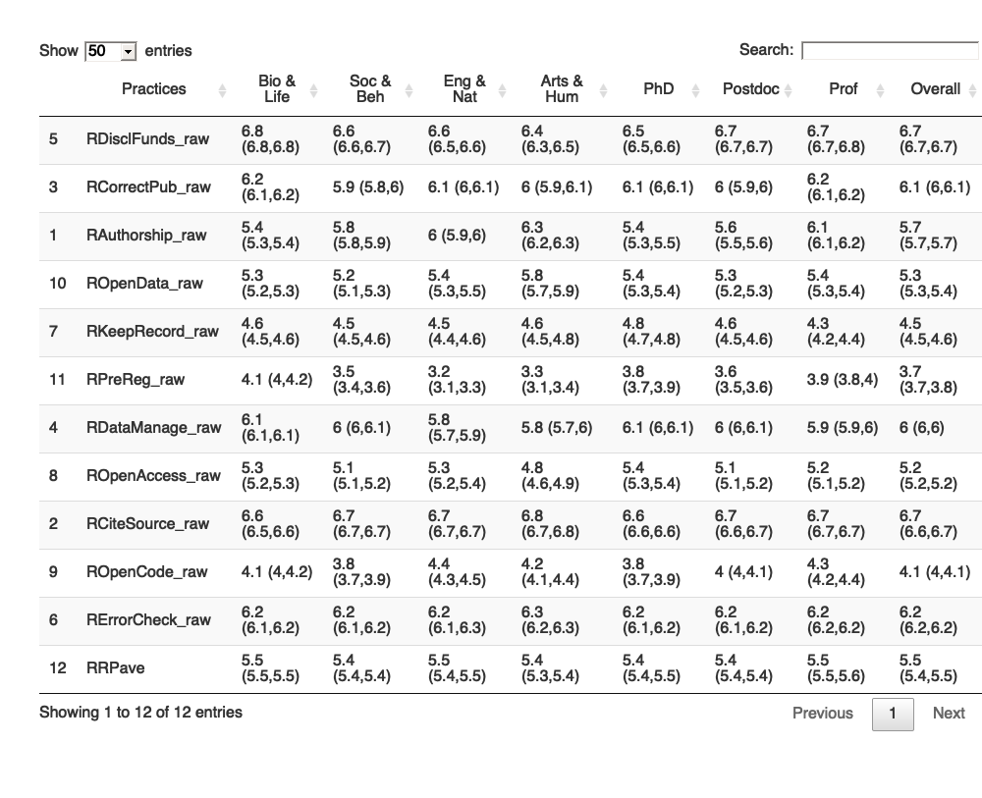
## Practices Bio & Life Soc & Beh Eng & Nat Arts & Hum
## 5 RDisclFunds_raw 6.8 (6.8,6.8) 6.6 (6.6,6.7) 6.6 (6.5,6.6) 6.4 (6.3,6.5)
## 3 RCorrectPub_raw 6.2 (6.1,6.2) 5.9 (5.8,6) 6.1 (6,6.1) 6 (5.9,6.1)
## 1 RAuthorship_raw 5.4 (5.3,5.4) 5.8 (5.8,5.9) 6 (5.9,6) 6.3 (6.2,6.3)
## 10 ROpenData_raw 5.3 (5.2,5.3) 5.2 (5.1,5.3) 5.4 (5.3,5.5) 5.8 (5.7,5.9)
## 7 RKeepRecord_raw 4.6 (4.5,4.6) 4.5 (4.5,4.6) 4.5 (4.4,4.6) 4.6 (4.5,4.8)
## 11 RPreReg_raw 4.1 (4,4.2) 3.5 (3.4,3.6) 3.2 (3.1,3.3) 3.3 (3.1,3.4)
## 4 RDataManage_raw 6.1 (6.1,6.1) 6 (6,6.1) 5.8 (5.7,5.9) 5.8 (5.7,6)
## 8 ROpenAccess_raw 5.3 (5.2,5.3) 5.1 (5.1,5.2) 5.3 (5.2,5.4) 4.8 (4.6,4.9)
## 2 RCiteSource_raw 6.6 (6.5,6.6) 6.7 (6.7,6.7) 6.7 (6.7,6.7) 6.8 (6.7,6.8)
## 9 ROpenCode_raw 4.1 (4,4.2) 3.8 (3.7,3.9) 4.4 (4.3,4.5) 4.2 (4.1,4.4)
## 6 RErrorCheck_raw 6.2 (6.1,6.2) 6.2 (6.1,6.2) 6.2 (6.1,6.3) 6.3 (6.2,6.3)
## 12 RRPave 5.5 (5.5,5.5) 5.4 (5.4,5.4) 5.5 (5.4,5.5) 5.4 (5.3,5.4)
## PhD Postdoc Prof Overall
## 5 6.5 (6.5,6.6) 6.7 (6.7,6.7) 6.7 (6.7,6.8) 6.7 (6.7,6.7)
## 3 6.1 (6,6.1) 6 (5.9,6) 6.2 (6.1,6.2) 6.1 (6,6.1)
## 1 5.4 (5.3,5.5) 5.6 (5.5,5.6) 6.1 (6.1,6.2) 5.7 (5.7,5.7)
## 10 5.4 (5.3,5.4) 5.3 (5.2,5.3) 5.4 (5.3,5.4) 5.3 (5.3,5.4)
## 7 4.8 (4.7,4.8) 4.6 (4.5,4.6) 4.3 (4.2,4.4) 4.5 (4.5,4.6)
## 11 3.8 (3.7,3.9) 3.6 (3.5,3.6) 3.9 (3.8,4) 3.7 (3.7,3.8)
## 4 6.1 (6,6.1) 6 (6,6.1) 5.9 (5.9,6) 6 (6,6)
## 8 5.4 (5.3,5.4) 5.1 (5.1,5.2) 5.2 (5.1,5.2) 5.2 (5.2,5.2)
## 2 6.6 (6.6,6.6) 6.7 (6.6,6.7) 6.7 (6.7,6.7) 6.7 (6.6,6.7)
## 9 3.8 (3.7,3.9) 4 (4,4.1) 4.3 (4.2,4.4) 4.1 (4,4.1)
## 6 6.2 (6.1,6.2) 6.2 (6.1,6.2) 6.2 (6.2,6.2) 6.2 (6.2,6.2)
## 12 5.4 (5.4,5.5) 5.4 (5.4,5.4) 5.5 (5.5,5.6) 5.5 (5.4,5.5)

Prevalence of RRP items (RRP > 4) without NA’s in total
Prevalences are not affected as RRP prevalence is only considered for values (5, 6 and 7) 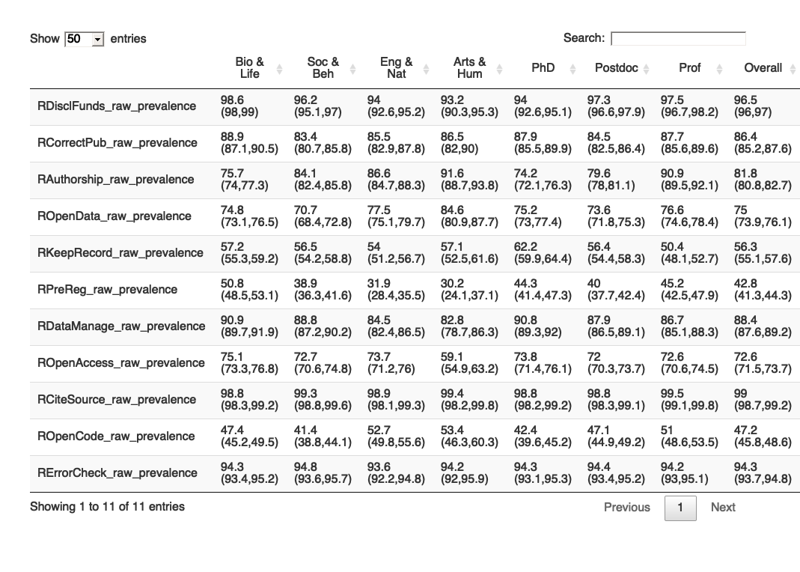
## Bio & Life Soc & Beh Eng & Nat
## RDisclFunds_raw_prevalence 98.6 (98,99) 96.2 (95.1,97) 94 (92.6,95.2)
## RCorrectPub_raw_prevalence 88.9 (87.1,90.5) 83.4 (80.7,85.8) 85.5 (82.9,87.8)
## RAuthorship_raw_prevalence 75.7 (74,77.3) 84.1 (82.4,85.8) 86.6 (84.7,88.3)
## ROpenData_raw_prevalence 74.8 (73.1,76.5) 70.7 (68.4,72.8) 77.5 (75.1,79.7)
## RKeepRecord_raw_prevalence 57.2 (55.3,59.2) 56.5 (54.2,58.8) 54 (51.2,56.7)
## RPreReg_raw_prevalence 50.8 (48.5,53.1) 38.9 (36.3,41.6) 31.9 (28.4,35.5)
## RDataManage_raw_prevalence 90.9 (89.7,91.9) 88.8 (87.2,90.2) 84.5 (82.4,86.5)
## ROpenAccess_raw_prevalence 75.1 (73.3,76.8) 72.7 (70.6,74.8) 73.7 (71.2,76)
## RCiteSource_raw_prevalence 98.8 (98.3,99.2) 99.3 (98.8,99.6) 98.9 (98.1,99.3)
## ROpenCode_raw_prevalence 47.4 (45.2,49.5) 41.4 (38.8,44.1) 52.7 (49.8,55.6)
## RErrorCheck_raw_prevalence 94.3 (93.4,95.2) 94.8 (93.6,95.7) 93.6 (92.2,94.8)
## Arts & Hum PhD Postdoc
## RDisclFunds_raw_prevalence 93.2 (90.3,95.3) 94 (92.6,95.1) 97.3 (96.6,97.9)
## RCorrectPub_raw_prevalence 86.5 (82,90) 87.9 (85.5,89.9) 84.5 (82.5,86.4)
## RAuthorship_raw_prevalence 91.6 (88.7,93.8) 74.2 (72.1,76.3) 79.6 (78,81.1)
## ROpenData_raw_prevalence 84.6 (80.9,87.7) 75.2 (73,77.4) 73.6 (71.8,75.3)
## RKeepRecord_raw_prevalence 57.1 (52.5,61.6) 62.2 (59.9,64.4) 56.4 (54.4,58.3)
## RPreReg_raw_prevalence 30.2 (24.1,37.1) 44.3 (41.4,47.3) 40 (37.7,42.4)
## RDataManage_raw_prevalence 82.8 (78.7,86.3) 90.8 (89.3,92) 87.9 (86.5,89.1)
## ROpenAccess_raw_prevalence 59.1 (54.9,63.2) 73.8 (71.4,76.1) 72 (70.3,73.7)
## RCiteSource_raw_prevalence 99.4 (98.2,99.8) 98.8 (98.2,99.2) 98.8 (98.3,99.1)
## ROpenCode_raw_prevalence 53.4 (46.3,60.3) 42.4 (39.6,45.2) 47.1 (44.9,49.2)
## RErrorCheck_raw_prevalence 94.2 (92,95.9) 94.3 (93.1,95.3) 94.4 (93.4,95.2)
## Prof Overall
## RDisclFunds_raw_prevalence 97.5 (96.7,98.2) 96.5 (96,97)
## RCorrectPub_raw_prevalence 87.7 (85.6,89.6) 86.4 (85.2,87.6)
## RAuthorship_raw_prevalence 90.9 (89.5,92.1) 81.8 (80.8,82.7)
## ROpenData_raw_prevalence 76.6 (74.6,78.4) 75 (73.9,76.1)
## RKeepRecord_raw_prevalence 50.4 (48.1,52.7) 56.3 (55.1,57.6)
## RPreReg_raw_prevalence 45.2 (42.5,47.9) 42.8 (41.3,44.3)
## RDataManage_raw_prevalence 86.7 (85.1,88.3) 88.4 (87.6,89.2)
## ROpenAccess_raw_prevalence 72.6 (70.6,74.5) 72.6 (71.5,73.7)
## RCiteSource_raw_prevalence 99.5 (99.1,99.8) 99 (98.7,99.2)
## ROpenCode_raw_prevalence 51 (48.6,53.5) 47.2 (45.8,48.6)
## RErrorCheck_raw_prevalence 94.2 (93,95.1) 94.3 (93.7,94.8)

Session Info
sessionInfo()
## R version 4.1.0 (2021-05-18)
## Platform: x86_64-apple-darwin17.0 (64-bit)
## Running under: macOS Big Sur 10.16
##
## Matrix products: default
## BLAS: /Library/Frameworks/R.framework/Versions/4.1/Resources/lib/libRblas.dylib
## LAPACK: /Library/Frameworks/R.framework/Versions/4.1/Resources/lib/libRlapack.dylib
##
## locale:
## [1] en_US.UTF-8/en_US.UTF-8/en_US.UTF-8/C/en_US.UTF-8/en_US.UTF-8
##
## attached base packages:
## [1] stats graphics grDevices utils datasets methods base
##
## other attached packages:
## [1] RRreg_0.7.1 tibble_3.1.2 psych_2.1.3 labelled_2.8.0 reshape2_1.4.4
## [6] ggplot2_3.3.4 DT_0.18 haven_2.4.1 purrr_0.3.4 magrittr_2.0.1
## [11] mice_3.13.0 dplyr_1.0.6
##
## loaded via a namespace (and not attached):
## [1] sass_0.4.0 tidyr_1.1.3 jsonlite_1.7.2 splines_4.1.0
## [5] foreach_1.5.1 tmvnsim_1.0-2 bslib_0.2.5.1 assertthat_0.2.1
## [9] highr_0.9 yaml_2.2.1 pillar_1.6.1 backports_1.2.1
## [13] lattice_0.20-44 glue_1.4.2 digest_0.6.27 minqa_1.2.4
## [17] colorspace_2.0-1 htmltools_0.5.1.1 Matrix_1.3-3 plyr_1.8.6
## [21] pkgconfig_2.0.3 broom_0.7.7 scales_1.1.1 webshot_0.5.2
## [25] processx_3.5.2 lme4_1.1-27 generics_0.1.0 ellipsis_0.3.2
## [29] withr_2.4.2 mnormt_2.0.2 crayon_1.4.1 evaluate_0.14
## [33] ps_1.6.0 fansi_0.5.0 doParallel_1.0.16 nlme_3.1-152
## [37] MASS_7.3-54 forcats_0.5.1 tools_4.1.0 hms_1.1.0
## [41] lifecycle_1.0.0 stringr_1.4.0 munsell_0.5.0 callr_3.7.0
## [45] compiler_4.1.0 jquerylib_0.1.4 rlang_0.4.11 grid_4.1.0
## [49] nloptr_1.2.2.2 iterators_1.0.13 htmlwidgets_1.5.3 crosstalk_1.1.1
## [53] rmarkdown_2.9 boot_1.3-28 gtable_0.3.0 codetools_0.2-18
## [57] DBI_1.1.1 R6_2.5.0 knitr_1.33 utf8_1.2.1
## [61] stringi_1.6.2 parallel_4.1.0 Rcpp_1.0.6 vctrs_0.3.8
## [65] tidyselect_1.1.1 xfun_0.23

Document info
Signed: Gerko Vink,
timestamp()
## ##------ Thu Jul 1 21:37:24 2021 ------##

END of DOCUMENT

